Slice buffer design

Table of Contents

1. Overview for new design 2

1.1 Origin design 2

1.1.1. Single thread 2

1.1.2. Multi thread 3

1.2 New design in review 4

1.2.1 Single thread 4

1.2.2. Multi-thread 5

2. Slice Buffer and thread 6

2.1 Before encoding one layer 6

2.2. Normal case for thread index and slice buffer index 8

2.3. Encoded slice num is not the same among threads 9

2.4. Different thread index in the same slice buffer 11

2.5. Slice index out-of-order case 12

2.6. Dynamic slice mode case1 13

2.7. Dynamic slice mode case2 14

2.8 Slice index in different slice mode 15

3. Slice Buffer Init/Update/Reorder 16

3.1. Allocate and initial before encoding first IDR 16

3.2 Init slice buffer info before encoder one layer 17

3.3.1 basic flow chart for encoding one slice task 18

3.3.2 Task manager 19

3.3.3. InitTask before encode one slice 20

3.3.4 Slice buffer update/reallocate during execute task 21

3.4. Slice buffer update after encoder one layer 22

3.4.1. ppSliceInLayer update 22

4. Final design 24

4.1 overall flow chart 24

4.2. functions for new design 26

4.2.1 Reallocate module 26

4.2.2 Extend layer buffer module 26

4.2.3. Reorder slice buffer module 26

4.2.4 other functions for new design 27

5. Buffer Structure 28

4.1. Slice Bs buffer 28

4.2. Frame bs buffer 29

4.3 pCtx-pOut 30

6. Other design 31

6.1. dynamic slice, slice boundary strategy 31

# Overview for new design

## 1.1 Origin design

SSlice* pSliceInLayer // slice buffer for all slices in layer

### 1.1.1. Single thread

pSliceInLayer

…

…

…

Slc3

Slc2

Slc1

Slc0

**reallocate** when current slice index larger than max slice num

…

pSliceInLayer

Slc2

Slc1

Slc0

Slc0

Slc1

Slc2

…

…

…

…

### 1.1.2. Multi thread

pSliceInLayer

Slc0

Slc1

Slc2

Slc3

…

…

Thrd0

Thrd1

**reallocate** when current slice index larger than max slice num ,

--step 0: thread[0] detect that current slice index larger than max slice num;

--step 1: thread[0] need to wait thread[1] completed current slice encoding task

--step 2: thread[1] stop slice encoding and thread[0] reallocate slice buffer,

--step 3: thread[0]/thread[1] start to encode new slice

pSliceInLayer

Slc0

Slc1

Slc2

...

**Step 0/1**

Thrd1

Thrd0

Thrd0

pSliceInLayer

Slc0

Slc1

Slc2

…

**Step 2**

Slc0

Slc1

Slc2

...

…

…

…

**Step 3**

Thrd1

Thrd0

## 

## 1.2 New design in review

SSlice** ppSliceInLayer; // point to actual slice buffer

typedef struct TagSliceBufferInfo {

SSlice*              pSliceBuffer;  // slice buffer for multi thread,

int32_t             iMaxSliceNum;

int32_t              iCodedSliceNum;

}SSliceBufferInfo;

### 1.2.1 Single thread

Slc0

Slc1

Slc2

…

ppSliceInLayer

[0]->pSliceBuffer

Slc0

Slc1

Slc2

…

**reallocate** when current slice index larger than max slice num

Slc0

Slc1

Slc2

…

ppSliceInLayer

[0]->pSliceBuffer

Slc0

Slc1

Slc2

…

Slc0

Slc1

Slc2

Slc3

…

…

**reallocate**

…

Slc0

Slc1

Slc2

Slc3

…

### 1.2.2. Multi-thread

Slc0

Slc1

Slc2

Slc3

Slc4

…

ppSliceInLayer

[0]->pSliceBuffer

Slc4

Slc2

Slc0

…

Slc1

Slc3

Slc5

…

[1]->pSliceBuffer

**for reallocate**, each thread will do it independently, and will update ppSliceInLayer by ***main thread*** when all slices in layer are encoded.

ppSliceInLayer

…

Slc4

Slc3

Slc2

Slc1

Slc0

**Main thread**

Slc0

Slc1

Slc2

Slc3

Slc4

…

…

Slc4

Slc2

Slc0

…

…

Slc0

Slc2

Slc4

…

…

Slc1

Slc3

Slc5

…

…

**Thread 1**

[0]->pSliceBuffer

**Reallocate**

**/update**

**Reallocate**

**Thread 0**

[1]->pSliceBuffer

# 2. Slice Buffer and thread

## 2.1 Before encoding one layer

the status of slice buffer and thread :

example:

thread: 3 threads

slices: 9 slices in layer

bThreadBufferUsage[iThrdIdx] = false

**Slice buffer**

[1]->pSliceBuffer

[2]->pSliceBuffer

[0]->pSliceBuffer

Thrd_0

**Idle**

**thread**

Thrd_2

Thrd_1

Get_UnUsed_Buffer()

slice in layer

Get_Idle_Thrd()

Slc8

Slc1

Slc2

Slc0

….

**Slice tasks**

Get_waiting_task()

**Task manager**

Encode_One_Slice()

Query thread buffer function:

int32_t CWelsSliceEncodingTask::QueryEmptyThread (bool* pThreadBsBufferUsage) {

  for (int32_t k = 0; k < MAX_THREADS_NUM; k++) {

    if (pThreadBsBufferUsage[k] == false) {

      pThreadBsBufferUsage[k] = true;

      return k;

    }

  }

  return -1;

}

Example:

k=1, means that encoding slice task using [0]->pSliceBuffer as slice buffer

Query IDLE thread for slice task function:

CWelsTaskThread*   CWelsThreadPool::GetIdleThread() {

  CWelsAutoLock cLock (m_cLockIdleTasks);

  if (m_cIdleThreads->size() == 0) {

    return NULL;

  }

  CWelsTaskThread* pThread = m_cIdleThreads->begin();

  m_cIdleThreads->pop_front();

  return pThread;

}

## 2.2. Normal case for thread index and slice buffer index

**Task manager**

Thrd_2

Slice_2

[2]->pSliceBuffer

Thrd_1

Slice_1

[1]->pSliceBuffer

Thrd_0

Slice_0

[0]->pSliceBuffer

Thrd_2

Slice_8

[2]->pSliceBuffer

…

…

…

Final map for thread index and slice buffer index, slice index

ppSliceInLayer

Slc0

Slc1

Slc2

Slc3

…

Slc8

[0]->pSliceBuffer

Slc6

Slc3

Slc0

Slc1

Slc4

Slc7

[1]->pSliceBuffer

Thrd_0

Thrd_1

Thrd_2

[2]->pSliceBuffer

Slc8

Slc5

Slc2

## 2.3. Encoded slice num is not the same among threads

case 1:

ppSliceInLayer

Slc0

Slc1

Slc2

Slc3

…

Slc8

Slc0

Slc3

[0]->pSliceBuffer

Thrd_0

Thrd_1

Slc7

Slc1

Slc4

[1]->pSliceBuffer

Slc6

Thrd_2

[2]->pSliceBuffer

Slc8

Slc5

Slc2

case 2:

encode time for Slc0 and Slc_2 are longer than Slc1, Slc3~Slc8

ppSliceInLayer

Slc0

Slc1

Slc2

Slc3

…

Slc8

Slc0

[0]->pSliceBuffer

Thrd_0

Thrd_1

Slc8

Slc1

Slc3

[1]->pSliceBuffer

…

Thrd_2

[2]->pSliceBuffer

Slc2

Corner case 1, no encoded slice for one thread:

Thread_0 and Thread_1 are fast enough and always get CPU resource,

Thread_2 is under waiting status/IDLE status.

ppSliceInLayer

Slc0

Slc1

Slc2

Slc3

…

Slc8

Slc0

Slc2

[0]->pSliceBuffer

Thrd_0

Thrd_1

Slc7

Slc1

Slc3

[1]->pSliceBuffer

…

Thrd_2

[2]->pSliceBuffer

Corner case 2, all slices encoded by one thread :

Thread_0 is fast enough and always get CPU resource,

Thread_1 and Thread_2 are under waiting status/IDLE status.

ppSliceInLayer

Slc0

Slc1

Slc2

Slc3

…

Slc8

Thrd_0

…

Slc1

Slc0

Slc8

[0]->pSliceBuffer

Thrd_1

[1]->pSliceBuffer

Thrd_2

[2]->pSliceBuffer

## 2.4. Different thread index in the same slice buffer

Timing diagram for Thread—SlcTask—ThreadBuffer



## 2.5. Slice index out-of-order case



## 2.6. Dynamic slice mode case1

**Partition_0**: **Slc0, Slc3**

Slc0

Slc3

**Partition_1:** **Slc1, Slc4,Slc7,Slc10**

Slc1

Slc4

Slc7

Slc10

Slc5

Slc2

**Partition_2:** **Slc2, Slc5, Slc8**

Slc8

**Slice_Index** = PartitonID + Partition_Num * Slice_Index_InPartition

Example: the 2nd slice in partition 1, Slice_Indx = 1 + 3 * 2 = Slc7

the 3th slice in partition 2 , Slice_Index = 2 + 3* 1 = Slc5

**Slice_Index_InLayer** = PartitonOffset [Partiton_ID]+ Slice_Index / Partition_Num

Here in example, PartitonOffset[0] = 0;

PartitonOffset[1] = 0 + 2 =2;

PartitonOffset[2] = 0 + 2+ 4 = 6;

Slc7 = PartitonOffset[1] + 7 / 3 = 2 + 2 = 4; So, ppSliceInLayer[4] = Slc7

Slc8

…

Slc3

Slc2

Slc1

Slc0

ppSliceInLayer

Slc2

Slc5

Slc8

[2]->pSliceBuffer

Thrd_2

Slc7

[1]->pSliceBuffer

Slc4

Slc1

Thrd_1

Slc10

Slc0

Slc3

[0]->pSliceBuffer

Thrd_0

## 2.7. Dynamic slice mode case2

**Thread_0 encoded two partitions**

**while no partition for Thread_2**

**Partition_0**: **Slc0, Slc3**

Slc0

Slc3

**Partition_1:** **Slc1, Slc4,Slc7,Slc10**

Slc1

Slc4

Slc7

Slc10

Slc5

Slc2

**Partition_2:** **Slc2, Slc5, Slc8**

Slc8

**Slice_Index** = PartitonID + Partition_Num * Slice_Index_InPartition

Example: the 2nd slice in partition 1, Slice_Indx = 1 + 3 * 2 = Slc7

the 3th slice in partition 2 , Slice_Index = 2 + 3* 1 = Slc5

**Slice_Index_InLayer** = PartitonOffset [Partiton_ID]+ Slice_Index / Partition_Num

Here in example, PartitonOffset[0] = 0;

PartitonOffset[1] = 0 + 2 =2;

PartitonOffset[2] = 0 + 2+ 4 = 6;

Slc7 = PartitonOffset[1] + 7 / 3 = 2 + 2 = 4; So, ppSliceInLayer[4] = Slc7

Slc8

…

Slc3

Slc2

Slc1

Slc0

ppSliceInLayer

[2]->pSliceBuffer

Slc7

[1]->pSliceBuffer

Slc4

Slc1

Slc10

Thrd_0

Slc8

Slc5

Slc2

Slc0

Slc3

[0]->pSliceBuffer

Thrd_2

Thrd_1

## 2.8 Slice index in different slice mode

Dynamic slice mode

**Partition_0**: **Slc0, Slc3**

Slc0

Slc3

**Partition_1:** **Slc1, Slc4,Slc7,Slc10**

Slc1

Slc4

Slc7

Slc10

Slc5

Slc2

Slc8

**Partition_2:** **Slc2, Slc5, Slc8**

Slc0

Slc1

Slc2

Slc3

…

Slc8

ppSliceInLayer

Non-dynamic slice mode

Slc0

Slc1

…

Slc8

Slc2

Slc3

# 3. Slice Buffer Init/Update/Reorder

## 3.1. Allocate and initial before encoding first IDR

1. Allocate [0]->pSliceBuffer, [1] ->pSliceBuffer, etc.

here pSliceInThread has the same meaning with [0/1/2…]->pSliceBuffer

1. Allocate ppSliceInLayer buffer
2. Allocate pFirstMbIdxOfSlice and pCountMbNumInSlice buffer

Init slice boundary info



## 3.2 Init slice buffer info before encoder one layer

* Set iCodedSliceNum = 0 for all thread buffer
* Set iSliceIdx = -1 for all slice buffer (will set to actual slice idx during encoding one slice)
* Init RC info for all slice level parameters using ppSliceInLayer[iSlcIdx]
* Init reference pic info for all slices using ppSliceInLayer[iSlcIdx]



**3.3 Slice buffer init/update/reallocate during encoding one slice**

### 3.3.1 basic flow chart for encoding one slice task

* Task manager: Get idle thread, unused thread buffer, and encoding slice
* Init task: Init slice boundary info etc.
* Excute task: Encode one slice etc



### 3.3.2 Task manager

* Get unused thread buffer, in this example, choose Buf_1 as slice buffer
* Get Idle thread, thread_2
* Get encode slice index in layer which will be encoded in this task, Slc_7



### 3.3.3. InitTask before encode one slice

* init rc with boundary info

*GomRCInitForOneSlice()*

* update next slice boundary(start MB index etc.)



### 3.3.4 Slice buffer update/reallocate during execute task

* check whether need to reallocate
* init m_pSlice buffer
* update thread buffer info, iCodeSliceNum ++



## 3.4. Slice buffer update after encoder one layer

### 3.4.1. ppSliceInLayer update

extend and reallocate ppSliceInLayer buffer,

ppSliceInLayer buffer num == All thread slice buffer num



3.4.2. Slice buffer reorder

example 1



# 4. Final design

## 4.1 overall flow chart

 pDqLayer->bThreadSlcBufferFlag =

(pCtx->pSvcParam->iMultipleThreadIdc > 1 &&

         SM_SIZELIMITED_SLICE == pSliceArgument->uiSliceMode) ? true : false;

* bThreadSlcBufferFlag = fase, keep origin design
* bThreadSlcBufferFlag = true, using new buffer design



Example



## 4.2. functions for new design

### 4.2.1 Reallocate module

bNeedReallocate = (pCurDq->sSliceBufferInfo[m_iThreadIdx].iCodedSliceNum >=

pCurDq->sSliceBufferInfo[m_iThreadIdx].iMaxSliceNum -1)

? true : false;

if (bNeedReallocate) {

   WelsMutexLock (&m_pCtx->pSliceThreading->mutexThreadSlcBuffReallocate);

   //for memory statistic variable

   iReturn = ReallocateSliceInThread(m_pCtx, pCurDq, m_pCtx->uiDependencyId,

m_iThreadIdx);

   WelsMutexUnlock (&m_pCtx->pSliceThreading->mutexThreadSlcBuffReallocate);

  if (ENC_RETURN_SUCCESS != iReturn) {

     return iReturn;

  }

}

### 4.2.2 Extend layer buffer module

  //reallocate ppSliceInLayer if total encoded slice num exceed max slice num

  if (iMaxSliceNum > pCtx->pCurDqLayer->iMaxSliceNum) {

    iRet = ExtendLayerBuffer(pCtx, pCtx->pCurDqLayer->iMaxSliceNum, iMaxSliceNum);

    if (ENC_RETURN_SUCCESS != iRet) {

      return iRet;

    }

    pCtx->pCurDqLayer->iMaxSliceNum = iMaxSliceNum;

  }

### 4.2.3. Reorder slice buffer module

  //update ppSliceInLayer based on pSliceBuffer, reordering based on slice index

  iRet = ReOrderSliceInLayer (pCtx, kuiSliceMode, pCtx->iActiveThreadsNum);

  if (ENC_RETURN_SUCCESS != iRet) {

    WelsLog (& (pCtx->sLogCtx), WELS_LOG_ERROR,

             "CWelsH264SVCEncoder::SliceLayerInfoUpdate: ReOrderSliceInLayer failed");

    return iRet;

  }

### 4.2.4 other functions for new design

int32_t InitSliceList (SSlice*& pSliceList,

                       SBitStringAux* pBsWrite,

                       const int32_t kiMaxSliceNum,

                       const int32_t kiMaxSliceBufferSize,

                       const bool bIndependenceBsBuffer,

                       CMemoryAlign* pMa);

int32_t InitAllSlicesInThread (sWelsEncCtx* pCtx);

int32_t InitOneSliceInThread (sWelsEncCtx* pCtx,

                              SSlice*& pSlice,

                              const int32_t kiSlcBuffIdx,

                              const int32_t kiDlayerIdx,

                              const int32_t kiSliceIdx);

int32_t InitSliceInLayer (sWelsEncCtx* pCtx,

                          SDqLayer* pDqLayer,

                          const int32_t kiDlayerIndex,

                          CMemoryAlign* pMa);

int32_t ReallocateSliceList (sWelsEncCtx* pCtx,

                             SSliceArgument* pSliceArgument,

                             SSlice*& pSliceList,

                             const int32_t kiMaxSliceNumOld,

                             const int32_t kiMaxSliceNumNew);

int32_t ReallocateSliceInThread (sWelsEncCtx* pCtx,

                                 SDqLayer* pDqLayer,

                                 const int32_t kiDlayerIdx,

                                 const int32_t KiSlcBuffIdx);

int32_t ReallocSliceBuffer (sWelsEncCtx* pCtx);

int32_t GetCurLayerNalCount(const SDqLayer* pCurDq, const int32_t kiCodedSliceNum);

int32_t GetTotalCodedNalCount(SFrameBSInfo* pFbi);

int32_t FrameBsRealloc (sWelsEncCtx* pCtx,

                        SFrameBSInfo* pFrameBsInfo,

                        SLayerBSInfo* pLayerBsInfo,

                        const int32_t kiMaxSliceNumOld);

int32_t ReOrderSliceInLayer(sWelsEncCtx* pCtx,

                            const SliceModeEnum kuiSliceMode,

                            const int32_t kiThreadNum);

int32_t SliceLayerInfoUpdate (sWelsEncCtx* pCtx,

                              SFrameBSInfo* pFrameBsInfo,

                              SLayerBSInfo* pLayerBsInfo,

                              const SliceModeEnum kuiSliceMode);

# 5. Buffer Structure

## 4.1. Slice Bs buffer

**Slice Buffer**

**Recycle used**

1. For thread slices, refer to InitBits()

pCtx->pSliceThreading->pThreadBsBuffer

2. Single thread,

replace by pOut->pBsBuffer

SWelsSliceBs sSliceBs

SBitStringAux* pSliceBsa

……

……

iStartPos

iPayloadSize

pRawData

pEndBuf

pCurBuf

pStartBuf

iIndex

iLeftBits

uiCurBits

iBits

sNalExt

iNalIndex

sNalList[2]

pBs

uiSize

sBsWrite

iNalLen[2]

pBsBuffer

uiBsPos

pRawData

iPayloadSize

iStartPos

sNalExt

Slice Bs which will be write to layer bs buffer.

Single thread/slice mode set to null

sNalUnitHeader

bIdrFlag

uiPriorityId

iNoInterLayerPredFlag

uiDependencyId

uiQualityId

uiTemporalId

bUseRefBasePicFlag

bDiscardableFlag

bOutputFlag

uiReservedThree2Bits

uiLayerDqId

bNalExtFlag

uiForbiddenZeroBit

uiNalRefIdc

eNalUnitType

uiReservedOneByte

## 4.2. Frame bs buffer

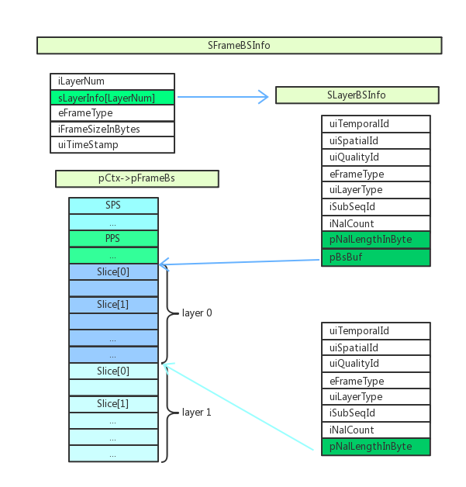

## 4.3 pCtx-pOut

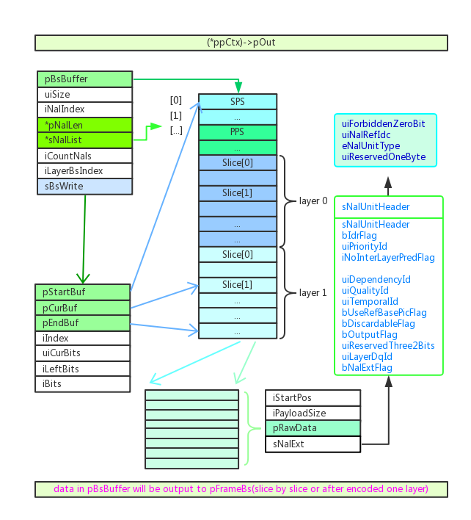

# 6. Other design

## 6.1. dynamic slice, slice boundary strategy

